Skating ‘n’ Racing

Initial Research and Planning

MOD002683

Professional and Entrepreneurial Portfolio

SID : 1409046

Contents

Brief 3

Research 3

Specification 4

Methodology & Plan 5

Appendices 6

Index 10

References 10

# Brief

This game will be a 2D racing game in which the player will be controlling a character on a skateboard, racing against either a clock or other competitors. There will be a ‘story’ mode where you can race through different competitions based in various locations across the world. The level design will be based on stereotypical features of the countries that I choose to involve. Once one country is complete there will be the option to move onto the next, with the game getting progressively harder until the final race is unlocked. There will be pick-ups (e.g. boosts, weapons) that will be used without any input from the user in this mode. [For potential second game mode see Appendix 1]

The reason I wanted to make this game is because I have recently enjoyed racing games and am excited by the way the mobile platform integrates with the genre, especially with 2D racing games. Furthermore, I am wanting to pursue a career as a programmer, therefore would like to expand my portfolio into mobile games that will aid me in becoming more a versatile candidate.

# Research

The main platform I am aiming this game at is the mobile market. I will also be producing a standalone version for marking. Mobile platform is my main target as this is an area of personal interest and a field I haven’t yet explored. Potential revenue streams include various add-ons via in-app purchases. Examples would include; better skateboards allowing you to travel faster, deployable speed boosts, weapons to slow other players, extra levels for players to buy etc. [For mobile games industry research see Appendix 2]

The statistics in appendix 2 lead me to believe that this game is best aimed at the mobile market and with growth only predicted to grow, if this game was deployed into the market it would be entering a strong marketplace. The highest majority of games played came under the category ‘casual’ therefore, I have decided to make the art style fit that genre. This will hopefully make the game more appealing to most gamers as it gives the impression of a more casual gaming experience. To further support the shift towards a more casual experience in racing games the average time spent playing the top three racing games on Steam were all below 10 minutes.

The racing game genre is still succeeding; this is evident in appendix 2 which outlines how many of the top sports games are racers. This gives me confidence that racing is still a popular genre to build a game for, with impressive sales figures for mobile downloads in this genre as recently as last year.

There are many successful racing games on the market, including the ‘Hill Climb’ series in which your character is ‘attempting the ride where no one else has before and conquering the highest hills on the moon’. The second instalment of the series is #100 in the top free games of any category (as of 12/02/2017). [For more market analysis of Apple App Store see Appendix 3] There are inevitably games in this genre that have failed as the application market has become flooded with games. 24.85% of apps downloaded from the Apple App Store are games (Statista, 2016), making it the highest grossing category by 15%, with business in second place. The failure of these games can be attributed to a number of reasons, including an unappealing USP (or in some cases a lack of entirely), improper testing and poor monetization strategy. The downfall with the largest consequences however, is poor user experience e.g. long loading times, slow or lagging games and features that are too difficult to access often.

# Specification

The game will be made in Unity version 5.4.1, with the scrips written in Visual Studio, and the language as C#. Most of the assets will be acquired from sprite sharing websites, for example; The Spriters Resource[1] and Pixel Joint[2]. I will also be using the unity asset store and will create some basic assets within the editor or websites like Piskel[3]. Any audio will be sourced from the internet as this is not an aspect of the game that I will be myself focusing on. As I explained above, I will be selecting assets that will give a lighter feel to the game and make it appear more casual [A mood board is available at appendix 7].

[A detailed breakdown of each step is available at appendix 5]

|  |  |  |
| --- | --- | --- |
| Task | Duration | Description |
| Player movement – Mobile | 2 Weeks | Creating player movement for mobile platform |
| Player movement – PC | 1 Week | Creating player movement for standalone |
| Level design | 2 Weeks | Designing levels for player to play |
| Opposition AI | 2 Weeks | Creating opposition for the player to race against |
| Pick-Ups | 1 Week | Creating boosts and weapons for player to interact with |
| Death State | 1 Week | Creating scenario for if the player dies |
| Menu Design | 1 Week | Designing and implementing menus for the user to navigate through the game on mobile and PC |

# Methodology & Plan

After reviewing the task at hand, I have decided to implement many of the characteristics of agile development, but without a real end user to release the game to on a regular basis and an overall short development time. I will also be incorporating aspects of waterfall development. As per the waterfall method, I will complete a task to its complete potential and then move onto the next task, aiming not return to this aspect of development again at least until testing the game. But unlike waterfall methodology there will be room for changes in the specific part of development and the overall goal of the project.

I have chosen this method, as with waterfall I can easily track how far along the development lifecycle I am and can also complete all of the development without input from an end user. This means that after consultation with a tutor I can complete the project plan with their backing. The parts of agile development that I am using allow the change of goals during development allowing me to update the task list if my goals for the project change.

For this task, I have set out 3 milestones. The hand-in for assessment 1, complete game mechanics by the end of the 12th week of development. The final milestone is hand-in and presentation. [A detailed plan is available in appendix 4] [A Gantt chart is available in appendix 6]. I will be updating the Gantt chart in excel each week to track my progress against my plan, allowing me to update any changes in the development schedule.

# Appendices

**Appendix 1**

There will potentially be a section in which you must travel as far along a course as possible before crashing/ falling off. The further along the track you go the energy you use, if you run out of energy this would also have the same effect of crashing. You will collect a chocolate bar or fizzy drink which will act like an energy source which will be usable without affecting the amount of normal energy the player uses.

**Appendix 2**

The mobile games industry grew by 21.3% on year in 2016 accounting for $36.9 billion making it the most popular device to buy games at 37% compared to 31% for console and 32% for PC gaming (Newzoo, 2016). This growth in mobile is only predicted to grow over the next three years with some predicting that Chinese games revenues alone could double to $11.1 billion by 2019 (Takahasi, 2016). In 2014 46% of games played most often were casual / social (Entertainment Software Association, 2014). During July 2016 in the US alone, the racing genre reached 10.8 million downloads on mobile device (Statista, 2016). Four of the top 10 sports games that have been downloaded on Steam are racing games (Ars Technica, 2017), with 3 entries from the ‘DiRT rally’[4] series in the top 10. Three of the four racing games have a median play time below 10 minutes (Ars Technica, 2017).

**Appendix 3**

The top game in the App store is also a racing game, Chameleon Run[5]. This could be classified as a platformer game but the objectives are like that of a time trail racing game. Chameleon Run’s USP is that you must change the character’s colour to match the floor that you are about to land on. My game will be more like the Hill Climb Racing[6] series in the way that you will be able to control the car when it is in mid-air as this will provide a greater challenge to user to not crash when racing through the course.

**Appendix 4**

I have set a milestone at the hand in of assessment 1 as I will have all the planning complete and can start development with confidence, with time scales in mind. The second milestone is to have completed the game mechanics by the end of the 12th week of development, this is to allow time to tweak the mechanics to fit how I envisioned the game playing and allows me to work on the documentation for hand-in and allows me time to prepare for the presentation in teaching week 11 or 12. The final milestone is hand-in and presentation.

**Appendix 5**

The first task to complete for the development of this project will be creating the player movement for the mobile platform, as this is the main target platform I will be focusing on getting this to work before any PC mechanics. The actual movement of the player will be pre-determined, you will control the balance by using the gyroscope to make sure he doesn’t fall over, there will be two buttons which will allow the user to do tricks and earn more points After I have finished the mobile mechanics I will move onto the PC version and complete to player movement for the standalone version, this will also include the timer to track how well the player is doing. After the movement aspect has been complete I will concentrate my efforts onto level design, here I will be setting out the courses the player will be navigating and ensuring the levels are playable from start to finish and are enjoyable.

Next I will work on the opposition AI, as the AI will not be interacting with the actual player, this will mainly be setting an animation of a skater going from start to finish, if the player activates a weapon the animation will slow down and there will be multiple finishing times for the opposition skaters. Pick-ups will be the next task after AI, these will include boosts and weapons for the player to use in the level that they are playing. The boost pickups will be in the form of an energy drink or chocolate bar, the weapons that I will include are oil slicks and exploding jam jars to slow down the other skaters. The last mechanic I will implement is the death state for the user. This will bring up a menu asking the user if they want to restart the current level or quit back to the story mode sub menu. Along with these mechanics I will also have a main menu, instructions menu, story mode menu, arcade menu, pause menu and a death screen.

**Appendix 6**

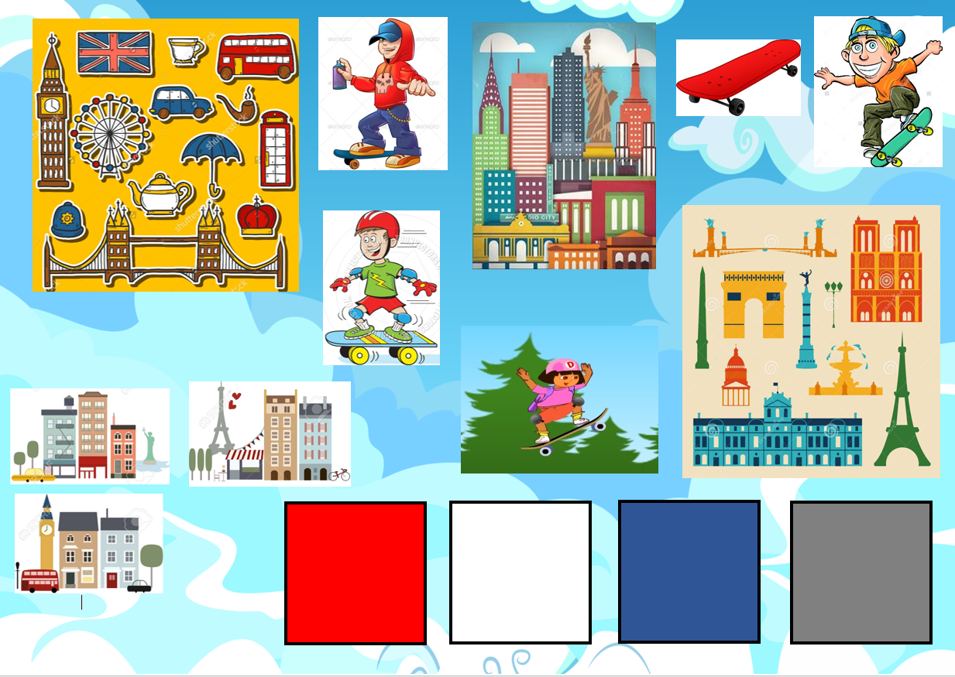**Appendix 7**

# Index

Apple App Store – Where customers can purchase applications for their Apple products.

USP - Unique Selling Point

AI – Artificial Intelligence

Steam - a multi-player platform developed by Valve Corporation. It is used to distribute games and related media online

# References

Ars Technica. (2017). *Top Games Released in Sports Genre [Online]*. Retrieved from https://steamspy.com/genre/Sports [Accessed 02/03/17]

Entertainment Software Association. (2014). Essential Facts About the Computer and Video Game Industry. 5. Retrieved from http://www.theesa.com/wp-content/uploads/2014/10/ESA_EF_2014.pdf [Accessed 02/03/17]

Newzoo. (2016). *2016 Global Games Market per Device [Online]*. Retrieved from https://newzoo.com/resources/ [Accessed 02/03/17]

Statista. (2016). *Most popular Apple App Store categories in December 2016, by share of available apps [Online]*. Retrieved from https://www.statista.com/statistics/270291/popular-categories-in-the-app-store/ [Accessed 02/03/17]

Statista. (2016). *Number of mobile game downloads in the United States in July 2016, by genre (in millions) [Online]*. Retrieved from https://www.statista.com/statistics/660728/mobile-game-downloads-in-the-us-by-genre/ [Accessed 02/03/17]

Takahasi, D. (2016). *Chinese mobile game revenues could double to $11.1B by 2019 [Online]*. Retrieved from www.venturebeat.com/2016/02/03/chinese-mobile-game-revenues-could-double-to-11-1b-by-2019/ [Accessed 02/03/17]

1. https://www.spriters-resource.com/
2. http://pixeljoint.com/
3. www.piskelapp.com/
4. DiRT Rally - http://store.steampowered.com/app/310560/
5. Chameleon Run - https://itunes.apple.com/gb/app/chameleon-run/id1084860489?mt=8
6. Hill Climb Racing - https://itunes.apple.com/gb/app/hill-climb-racing/id564540143?mt=8